**Online registration procedures – IELTS test**

**Step 1**

• Click below link to go to specific test session – 3 Dec 2022

<https://ielts.idp.com/book/IELTS?countryId=90&testCentreId=24&testVenueId=24&testCentreLocationId=29&testSessionDate=2022-12-03T00:00:00.0000000&isSelt=False&restrictToSpecifiedDate=true&testmoduleid=1&token=ab1631343395237db0ec7b72b4572cdcfc718d59449532b58d5455bb1c951f1c>

Registration Deadline: 25 Nov 2022

* The link will bring you to the session and proceed the registration step by step according to the instructions
* Please take note that the speaking test will be scheduled on the same day of written tests (Listening, Reading and Writing)
* Click “Continue” if you ensure to proceed to book the test

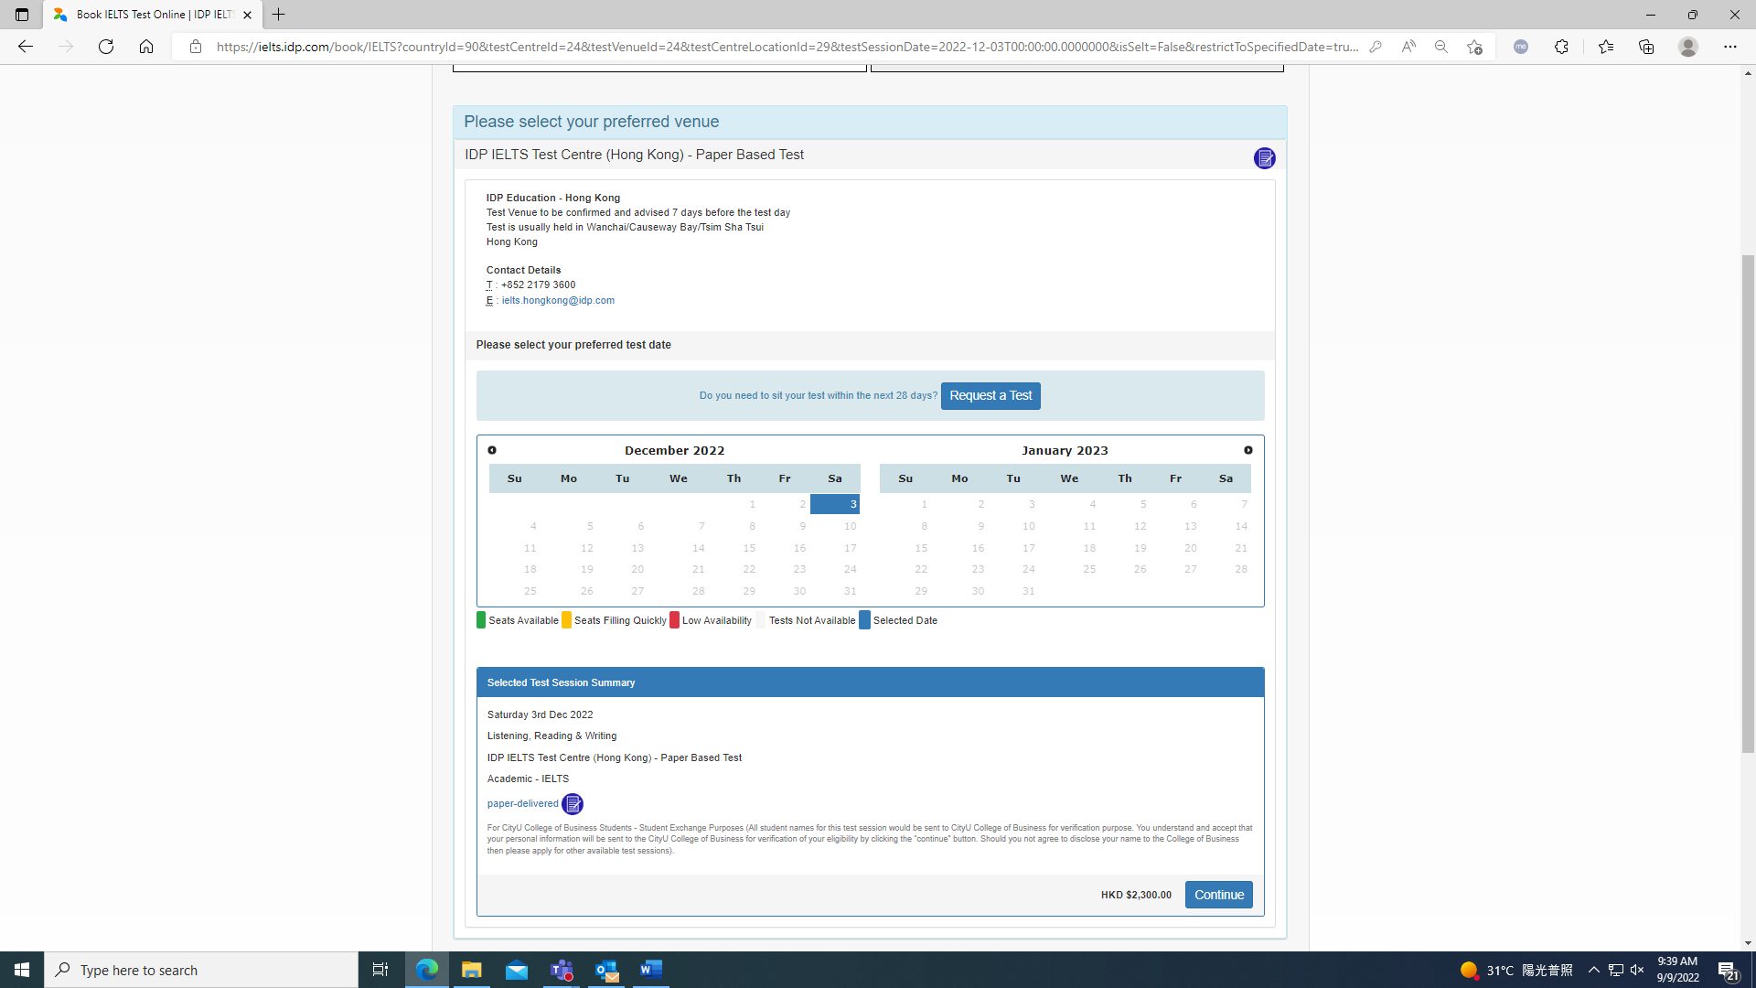

• Click “Seats Available” and continue

At this point if you wish to go ahead with the booking you can either:

• Select “**Login**” to use your existing account details if you already have them

**OR**

• “**Create New User**” to register for a new account and then finalise the booking.

In this example I am a new user so I will just select “**Create New User**”

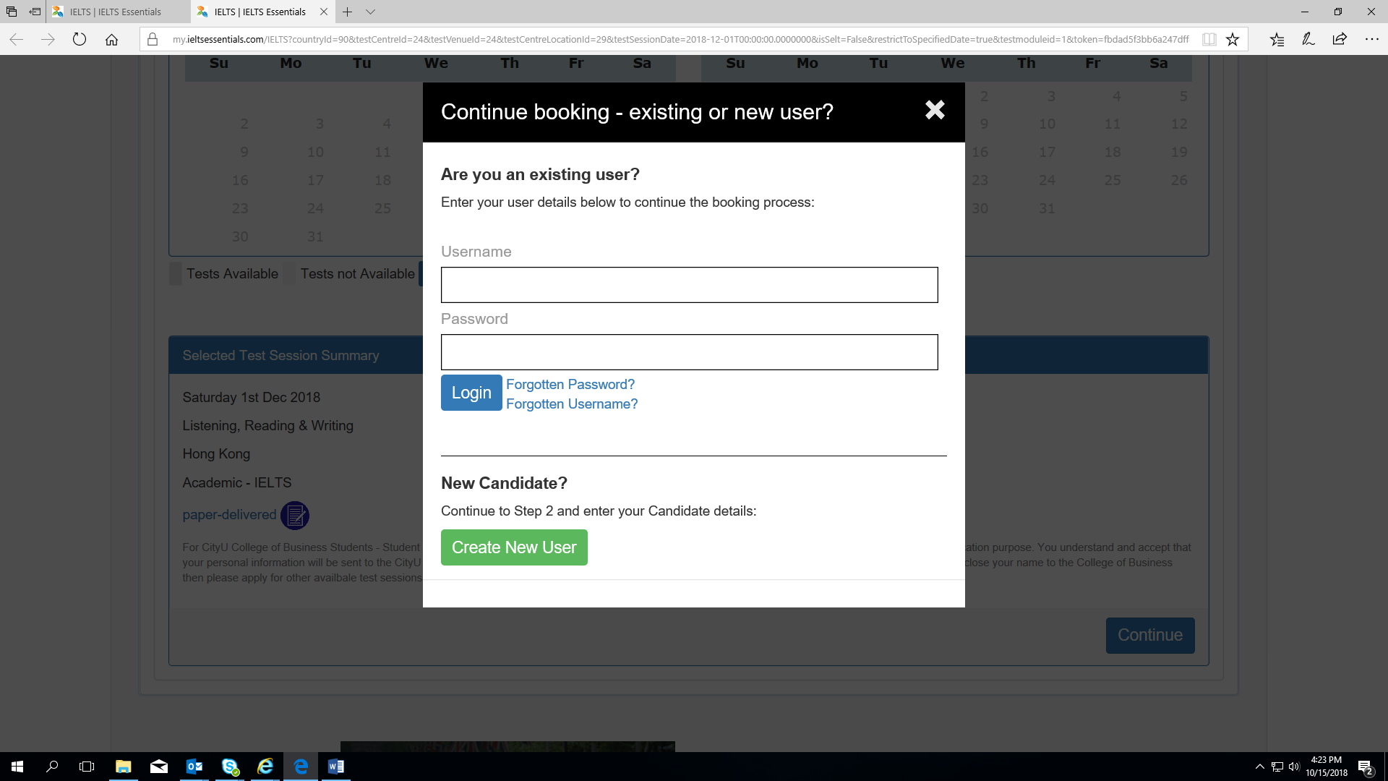

Fill in all the required fields and select “**Register**”

**Note:** If you log in as an **Existing User** all your details will be shown. You can edit them to make sure they are up to date and correct. Once you are happy with all the details select “**Continue**” to go to the next step.

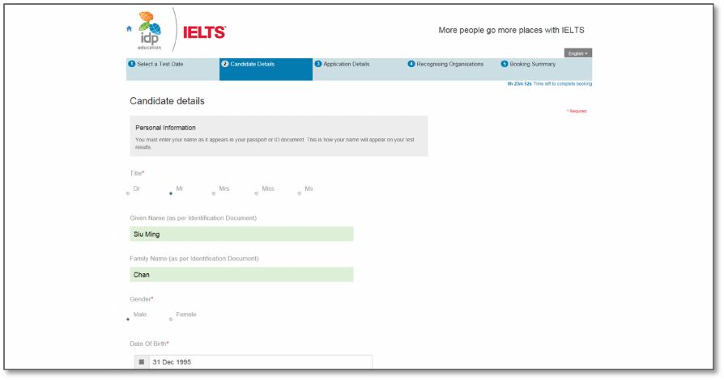

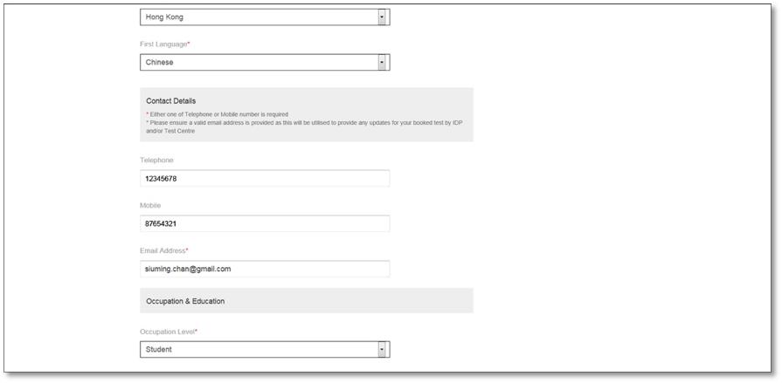

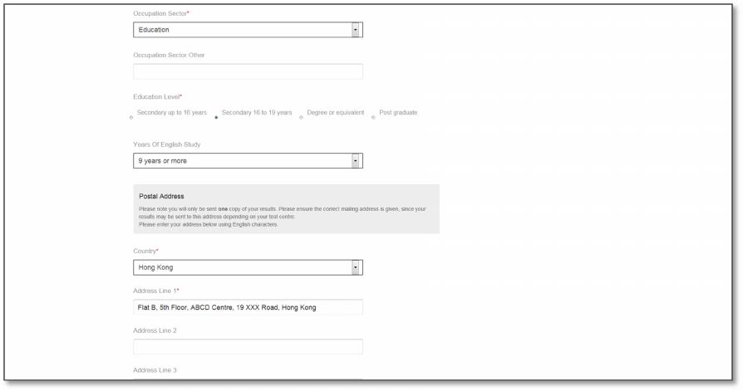

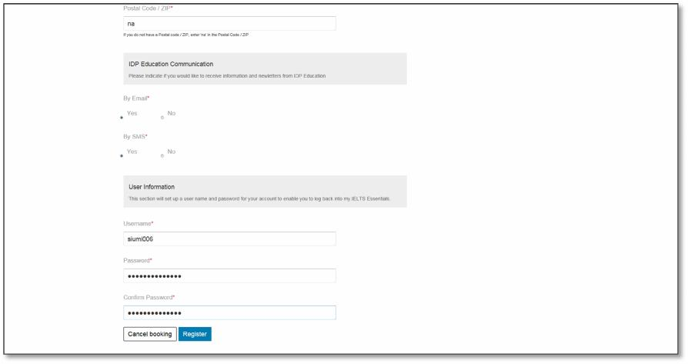

Read the Terms and Conditions, then check the box of “**I have read and agree to the Terms and Conditions**” to accept.

• Click “**Continue**”, the pop up screen will be closed

• Click “**Continue**” again to proceed

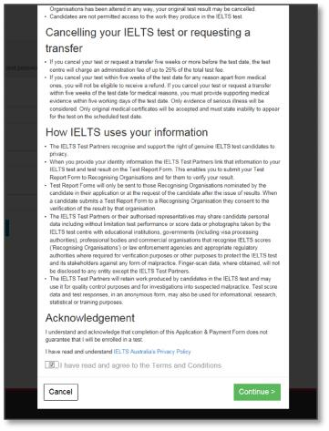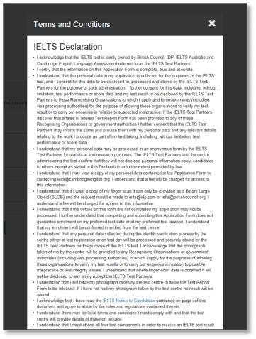

Fill in the Application Form

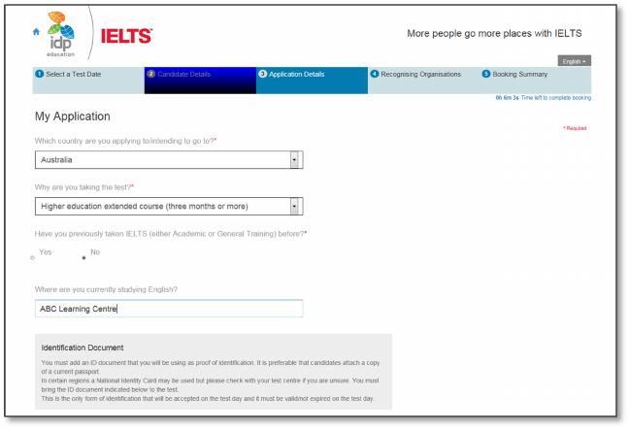

To add the identification number:

• enter your Hong Kong ID or Passport Number

• enter Expiry Date (If applicable)

• Scan the identification document (HKID card or Passport) into your Computer

Click “Browse” to locate the saved image of the document

Then Click “Upload Document”

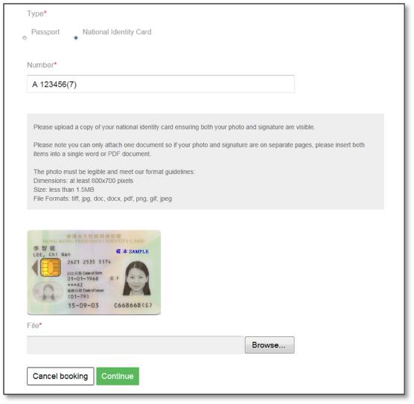

If you would like to send your IELTS results to the recognising organisation: Click “Add”

• select organisation from the drop-down list

• enter the name of the contact person, if required

• enter a case/file number, if appropriate

• click “**Save**” button

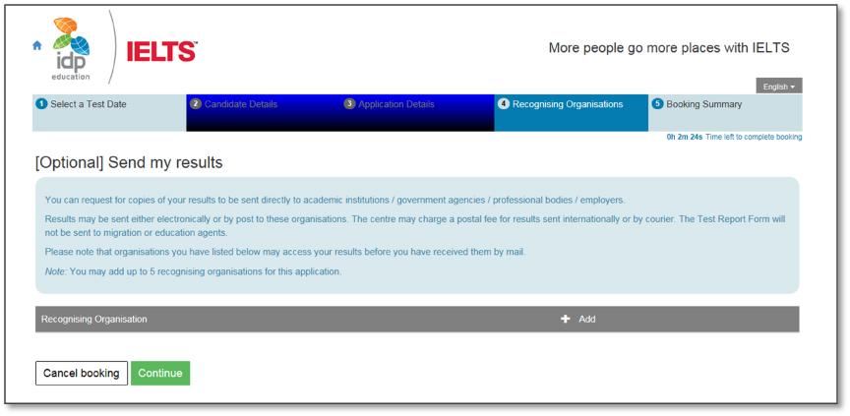

View the booking summary page. If necessary, you are able to edit the information entered by selecting the links in the Booking Wizard steps on the left side.

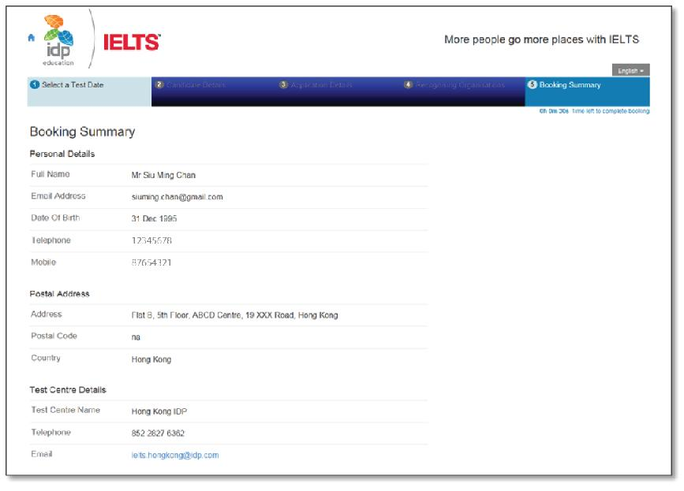

Before you can continue you will need to read the Terms & Conditions by clicking on the “**Click here to read and agree to the Terms and Conditions**” link

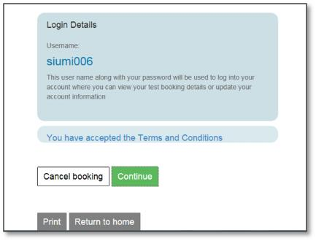

Select “**Pay Now**” to continue to the payment wizard and complete the booking.

**Note:** Selecting the link to “**Return to Booking**” will exit you out of the payment process and take you back to the “**Booking Summary”** page

**Note:** Selecting Cancel will cancel the entire booking and you will have to start over with a new test booking.

**Note:** Test fee: HK$2,300

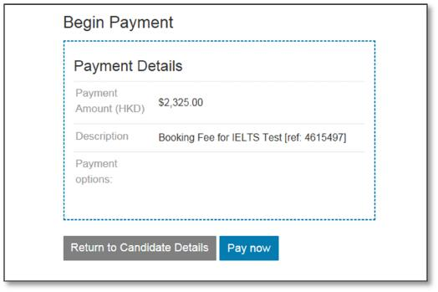

**Step 13**

Payment Method and Continue Payment Process

• Select payment method from the drop down list

• We accept PPS, Credit Card (Visa/Master) or PayPal.

(Note: If you pay by credit card, please click “PayPal”. However, you are not required to create a PayPal account, just simply click “**join as a guest**” in the PayPal payment gateway and follow the prompts to proceed the payment. Credit card or PayPal account to settle the payment of your test.)

For further details, please contact us at 2827 6362.

• Click **Continue**

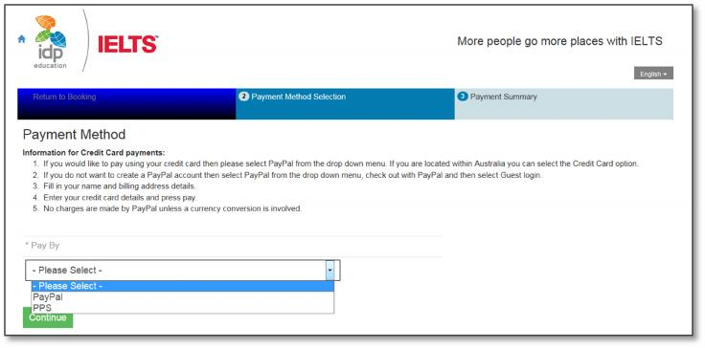

• Click on “**Check out with PayPal**” to proceed the payment.

• If you have a PayPal account, please **login** and process the payment. If you

do not have a PayPal Account, click **join as a guest** and follow the prompts to process the payment.

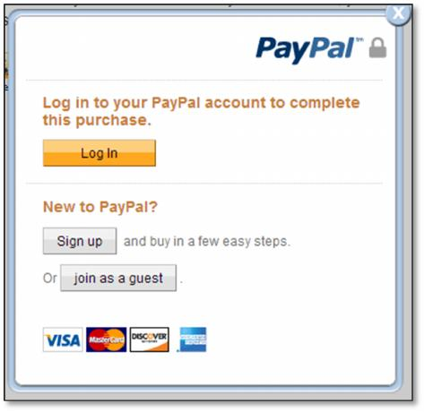

•  Select your credit card issuing country/region from the list and enter the details of your credit card. (The details must be the same as on your credit card). Click “**Continue**” to proceed.

•  You are required to enter the “p**hone number**” without the “**+**” Sign of the area code (e.g. For Hong Kong, you are only required to enter an 8 digits number “**XXXXXXXX**”)

• If your credit card is issued from any bank in Macau:

- Select “**China Worldwide**” and then “**Macau**” from the list.

- Select “**Macau**” in the field of “**Province or Municipality**”

- Enter “**Macau**” in the field of “**City/Country**”

- Enter “**000**” in the field of “**Postal code**”

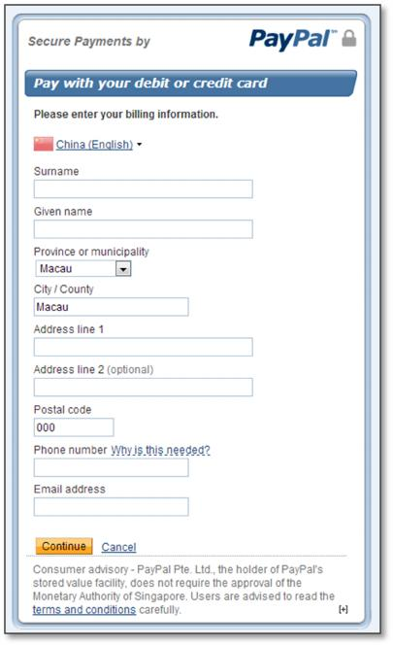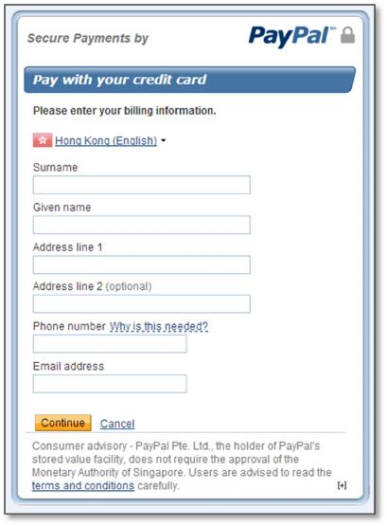

•  Enter your credit card number, type of the credit card (Master/Visa), expiry date and the CSC code (CSC code is printed at the back of the credit card), Click “**Continue**” to proceed.

•  Please double check if the payable amount and the credit card information are correct. Click on “**Pay Now**” to process payment.

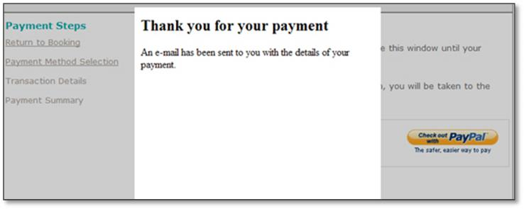

Acknowledgement

• A payment confirmation email will be sent to your nominated email address.

Your application will be verified after the payment is completed. You will be contacted by the test centre staff in

•  14 working days if your application documents are not compliant with IELTS requirements. The “Confirmation of Registration” document will be sent to you by email 4 to 5 days before the test date.

Please contact the test centre at 2179 3600 if you have questions about the online booking.